

Planote

# The Universal Organisation App

Splash Page : <http://www.projectbird.com/planote.html>

Web app : <http://robertjgabriel.github.io/Planote/#/dashboard>

**Interdisciplinary Group 3**

**Peter Bohane R00102054**

Bachelor of Arts (Honours) in Visual Communications, Year 3

**Brie Lloyd-Evans R00119556**

Bachelor of Arts (Honours) in Visual Communications, Year 3

**Robert Gabriel R00102430**

Bachelor of Science (Honours) in Web Development, Year 4

# Table of contents

What does the company do? 5

What specific problems are you addressing? 6

Origin of idea, how was the idea generated? 6

Customer Value Proposition 6

Value Creation Pitch 6

Outline any progress made to date 6

Company Structure 7

First Year Turnover & Profit. 7

Investment Required 7

First Year Goals 7

Year 2 & 3 Goals 8

The Product - Planote 8

Features 9

Advantages to Customers 9

Value Proposition 9

Unique Selling Point 10

Future Plans 10

Design Brief 10

Background Research 10

Design prototypes 12

Design Solution 12

Usability Issues 13

Does this product have the potential to be legally protected? 15

Is it legally protected? 15

Patent Number: 15

Not all product/services need to be patented. 15

Company Management Structure 16

What is the potential for employment in Ireland in this company? 17

Market Research 18

Market Trends or Issues 23

Customers 24

Competitors 25

Promotion 26

Place/Channels of Distribution 27

Business Opportunity 28

Pricing 29

Sales assumptions 30

Exports 31

Funding 31

Capital Costs 31

Fixed costs 32

Variable costs 32

# **Promoter Details**

**Name of Company:** Budgie App Development

**Name of Product:** Planote

**Name 1:**

Robert Gabriel

Faculty & Year: Bachelor of Science (Honours) in Web Development, Year 4

Full-time student

Telephone: 085 1499082

Email: robert.gabriel@mycit.ie

**Name 2:**

Peter Bohane

Faculty & Year: Bachelor of Arts (Honours) in Visual Communications, Year 3

Full-time Student

Telephone: 086 3051403

Email: peter.bohane@mycit.ie

**Name 3:**

Brie Lloyd-Evans

Faculty & Year: Bachelor of Arts (Honours) in Visual Communications, Year 3

Full-time Student

Telephone: 085 1325984

Email: brienne.lloyd-evans@mycit.ie

# Section 1 - Executive Summary

## What does the company do?

Budgie App Development is a mobile and web app development company founded in November 2015 in Cork, Ireland. It was founded by Robert Gabriel, Peter Bohane and Brie Lloyd-Evans. The company’s aim is to create problem solving apps, which are designed to be functional and beautifully crafted. Currently the company is working on designing and building one product, ‘Planote’, which is a timetable and notes app for students.

## What specific problems are you addressing?

* Timetable confusion
* Cross platform access
* Note organisation

## Origin of idea, how was the idea generated?

The idea of Planote was generated when discussing problems that students encounter on a daily basis. We found that we regularly forgot the start and end times of our classes, and almost no-one carries around their timetable print-out. Finding your timetable online is a long and arduous process. As you have your phone on you at most points throughout the day, it only makes sense to have an easy-to-access timetable on your phone. Combining this with a notes app solves the problem of note organisation. We found that we would often lose notes, but this app will help you organise your notes neatly and access them with ease from multiple platforms.

## Customer Value Proposition

For students who wish to increase their productivity, time management, and note organization this is the perfect all-in-one app. The cloud storage feature allows you access your notes and timetables from multiple platforms, and also share them with friends and classmates. It is an app that increases productivity, making learning faster and easier.

## Value Creation Pitch

Our research shows that this is an opportune time to break in to the app market. Our app is original, solves real issues for students and has the potential to be expanded to serve businesses and sports teams alike. By the end of our first year our total available market will be over 40 million consumers, and the promotion and marketing model we will have in place is designed to deliver maximum profits from this market.

## Outline any progress made to date

We currently have an Alpha version of our app designed and coded. Our extensive market research to date shows a need for this product and a huge market to exploit. Early feedback from our surveys, interviews and focus groups have provided nothing but positive feedback. We are currently working on having the product name and logo patented.

## Company Structure

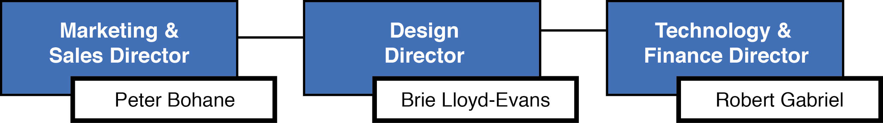

## First Year Turnover & Profit.

We expect turnover for the first year to be €26,950. The addition of investment to this figure, and the deduction of taxes, fees and expenses leaves us with a profit of €28,124 at the end of Year 1 of trading.

## Investment Required

We require a total of €35,000 funding in the first year. We intend to source this finance from ourselves, friends and families, and banks.

## First Year Goals

* Release a beta of ‘Planote’ to the Irish Google Play Store by 31/01/16.
* Update the layout and features of ‘Planote’ based on user feedback.
* Release the full app to the Irish Google Play Store by 01/04/16
* Release ‘Planote’ on the Irish Apple App Store by 01/06/16 thus doubling our target market.
* Release ‘Planote’ on the in multiple English-speaking countries on both the Google Play Store and the Apple App Store by 01/09/16, increasing our target market exponentially.
* Advertise and approach schools and colleges about partnerships in preparation for the start of the 2016/2017 school year.
* Break even financially in the first year of trading.

## Year 2 & 3 Goals

* In Year Two, we will extend the features ‘Planote’ to allow businesses and sports teams to use it. (rather than just students)
* Add support for multiple languages in ‘Planote’, and release the app to International App Stores by 01/08/2017, increasing our target market.
* Improve cloud server speeds and capacity to cater for more users by the beginning of the 2017/2018 school year.
* Make a Net Profit in Year 2 of trading.
* By the beginning of Year 3 we would hope to have up to 10 employees and ongoing plans to release a new App.
* Increase company brand recognition.
* Make a Net Profit in Year 3 of trading.
* Have a new App up and running a by 01/01/2019.

# See a steady increase in Year-on-Year turnover.

# Section 3A - Product or service

## The Product - Planote

Planote is an all-in-one Timetable and Notes Taking app for students. It allows the user to record their class timetable and take notes on that class within the very same app. Its intuitive design makes timekeeping easy, as you can check and update your college timetable on the go, while the Note-Taking feature makes it easy to organise your notes. The cloud based storage feature makes it easy to share your timetables and notes with friends and classmates, and also allows your to access your notes from anywhere, and on any device. In addition to these features, the app can also be used to track your upcoming tasks and assignments, your grades, and also your attendance.

## Features

* Simplicity for the user.
* Speedy performance.
* Personalization options.
* Cloud based storage.
* Multiple timetables.
* Note taking.
* Grade and Attendance tracking.
* Alerts for upcoming classes.

## Advantages to Customers

* Free to download.
* Better organization.
* Better time management.
* Better task management.
* Improves productivity.
* Ease of note access on multiple platforms at any time.

## Value Proposition

For students who wish to increase their productivity, time management, and note organization this is the perfect all-in-one app. There are very few apps on the app store who can offer this in one app, and none that do it as well as us.

The killer feature of our app is the cloud storage. The user can upload their timetables and notes to the cloud server, and access them via multiple platforms. As well as that, the cloud allows the user to share these timetables and notes with their friends and classmates. Planote is the ONLY app offering these features. Planote also provides support for integration with platforms such as blackboard and dropbox, allowing you to download notes uploaded by lectures and organise them in one convenient app.

The timetable feature of our app is quick and easy to use, you need only glance at the screen to know which class you are in next, and when. The notes taking section of our app is intuitively designed, and brings note organization to the next level. The app knows which class you are in (thanks to the timetable feature) and so when you take a note in that class, the app will automatically store the note under that subject. You can then search through your notes using the date, class, or subject. The app also allows you to track your upcoming tasks and assignments, your grades and also your attendance.

## Unique Selling Point

* Convenience of having your timetable, notes and tasks in one app.
* Intuitive and visually appealing design interface.
* Cloud Storage for your timetables and notes allowing:
  + The ability to access your timetables and notes on multiple platforms.
  + The ability to share timetables and notes with friends and classmates.

## Future Plans

We plan to release a beta app to the Google Play Store. Subsequently we will update and change the interface and features of the app as we receive feedback on this beta app. Following this, we plan to develop the app for the Irish Apple App Store as well as the Irish Google Play Store which will double our potential target market. Our main focus at this stage will be getting our product known in colleges, reaching out directly to our main target market. By August 2017 we hope to have support on the app for multiple languages, thus allowing us to release the app on International App stores, further expanding the target market. We also have plans to expand the features of the app to allow it to be used by businesses and sports teams alike.

# Section 3B Interface

## Design Brief

Identify a specific business opportunity and develop a media based solution using contemporary media devices and software.

## Background Research

### Existing Apps

As part of our design research we downloaded and used many existing apps from both the Google Play Store and the Apple App Store. We downloaded some popular notes apps, and some popular timetable apps. We also found some apps which integrated both, similar to ours. We examined how the interface looked, how it reacted to the user and how the user can navigate. We concluded that there were some good design elements to take from these existing apps, but we always felt we could improve on the designs.

### Material Design

Material Design is a design language developed by Google. It makes liberal use of grid-based layouts, responsive animations and transitions, padding, and depth effects such as lighting and shadows. Material Design will gradually be extended throughout Google's array of web and mobile products, providing a consistent experience across all platforms and applications. All good applications on the Google Play Store have now based their designs around the Material Design Guidelines. To aid designers, Google has released typefaces, icons and interface layouts that should be used when designing apps for their app store. We downloaded these useful resources and used them in our design.

As many popular apps on the Google Play Store have already began using the Material Design layouts, people have already become familiar with the way the navigation works. By using the Material Design guidelines, our users will find our app design instantly familiar and easy to navigate.

### Nielsen’s Usability Heuristics

While researching how to design for the user, we came upon Jakob Nielsen's 10 general principles for interaction design. They are called "heuristics" because they are broad rules of thumb and not specific usability guidelines:

1. Visibility of System Status
2. Match Between System and the Real World
3. User Control and Freedom
4. Consistency and Standards
5. Error Prevention
6. Recognition Rather Than Recall
7. Flexibility and Efficiency of Use
8. Aesthetic and Minimalist Design
9. Help Users Recognize, Diagnose, and Recover from Errors
10. Help and Documentation

Some of the main point we followed were

Accessibility

Application future growth would include support for different forms of disability aspects (visual, aural aids).

Speed and latency (Performance)

The interface shall have maximum response time of 1 second. Within that time user must be presented with the result of his actions or its confirmation.

Ease of use

The goal of the application is to allow the user to perform his main tasks and activities within 4 clicks. The navigational labels should be self explanatory and guide the user through each level of the website. It should also provide accurate feedback to make him confident that application works as expected. When it comes to error handling, it should stop the user from continuing if any occurs by giving proper feedback along with the choice of alternate route.

Learning

The application should be ready to be used by anyone who has very little technical knowledge of using internet. Any user should be able to use the core functionality of the application within few minutes and without prior training provided.

## Design prototypes

Several early design prototypes were drawn up on paper but lacked an overall theme to tie in the design. The design process started of as very generic and uninteresting. We concluded that we were designing too closely to the Material Design guidelines, and our app was lacking its own identity.

As we wanted our app to stand out, we needed to have a creative approach to the design of the app’s interface. In doing so, we had to also ensure that the interface was engaging and user friendly.

## Design Solution

After deciding on the product name ‘Planote’, we changed our design mentality. The lead designer, Brie, came up with a clever interface that played on the word ‘Planote’ but using planet shaped icons and outer-space visuals. Of course, this app’s target market is predominantly college students, so we did not want the interface to appear childish. We feel we have created an engaging, intuitive and mature interface that people will enjoy using. Importantly, the interface design adds to the functionality of the app.

**Testing**

As we worked on our design, we used a common method of testing called Hallway testing, which is asking several people to try and use our paper prototype types to do a set task. We were able to identify “brick walls”, in which the user was confused or couldn't finish the task. This testing helped identify usability issues, and allowed us to alter our design to help users navigate through the app with ease.

The Google Play Store allows developers to release early versions of apps to a select group of users, as alpha and beta testing versions. This allows the developer to fix any issues before the app is released widely. Once our app is ready to be published, we will release it as a beta on the Google Play Store. Subsequently we will update and change the interface and features of the app as we receive feedback on this beta app. This will allow us to ensure that we have a reliable working product when we decide to release the full app for download.

Also along with the use of testing it on several groups of children at a coderdojo.

## Usability Issues

The expression, “test early and often”, is particularly appropriate when it comes to usability testing. You should test as early as possible in the process using a variety of methods, assisting you in the development of content, Information architecture, visual design, interaction design and general user satisfaction.

Opportunities for testing include:

* Surveys, Interviews & Focus Groups to establish user goals
* Hallway testing
* Usability testing to gauge the user interaction end-to-end
* Satisfaction surveys to see how the site fares in the real world.

What we learnt was that use circle design was causing confusion as the users didn't understand what the colors meant. (See design 1A and design 1B) The design was changed to enhance the user understanding.

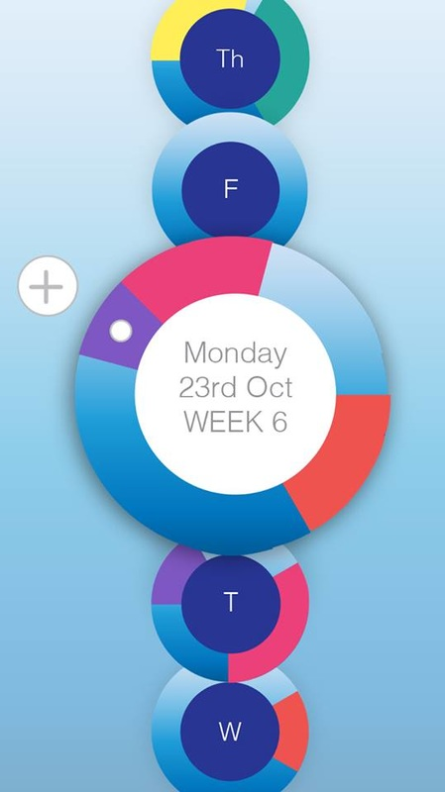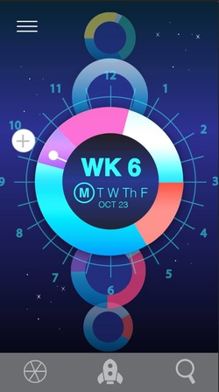

Design 1A Design 1B

Another issue was the user’s understanding of an icon based on previous experience. Due to the absence of a standard usage for most icons, text labels are necessary to communicate the meaning and reduce ambiguity.

As you can see from the icons below the use of the rocket as the home button was not understood straight away. This was poor design, so we changed it to a house. This was better understood by the user and the meaning as it is a commonly used icon for the home button.



Not understood Understood

# Section 4 - Intellectual Property

## Does this product have the potential to be legally protected?

No

## Is it legally protected?

No

## Patent Number:

N/A

## Not all product/services need to be patented. Have you looked at any other source e.g. copyright, nondisclosure, code protection, supplier source?

We are working on having the name and logo of the ~’Planote’ product copyrighted. Non-disclosure and code protection will also be in heavy use as there will no open source code when growing and inviting investors and business partners in. This will have to be enforced to make sure none of our ideas, assets or private information are leaked or stolen.

# Section 5 – People /Company

## Company Management Structure



**Marketing & Sales Director:**

Peter is the Marketing and Sales Director of the company. His job is to assume overall responsibility for developing the annual marketing plan for the organisation. He is required to analyse market trends, study competitor’s products and services and identify possible target markets. He will also be responsible for preparing marketing plans for our existing and new products in cooperation with his senior management colleagues.

It is also his responsibility to develop a sales strategy, implement a sales plan, and to develop plans to exploit marketing opportunities.

**Design Director:**

Brie is the Design Director of the company. Brie is responsible for overseeing all design aspects of our company's products and services, including product interface design, graphic design, user experience design and branding. She would also be expected to be working in close contact with the Marketing and Sales Director, as she would be responsible for developing graphics for any advertising campaigns the company runs. The design director oversees the creation of company and product branding.

**Technology & Finance Director:**

Robert is the Technology & Finance Director of the company. As technology director he is responsible for technological developments within the organization. He is expected to work closely with the Design Director, and will be responsible for the successful creation and delivery of the company's products to the marketplace by managing technical risks and opportunities.

As there are only three employees in this business at startup, Robert will also be the Financial Director in the first year. This position will make him responsible for managing the financial risks of the corporation. He is responsible for financial planning and record-keeping. We would also expect Robert to analyse financial data and to create financial reports for his fellow directors. He will also prepare the annual budget for the organisation.

## What is the potential for employment in Ireland in this company?

As stated in our business goals, we plan to have approximately 20 employees by the beginning of Year 3. As the number of employees in the company expands, the management structure will change. This will allow for greater productivity and a more efficient workflow. We plan to have a company structure similar to the one outlined below.

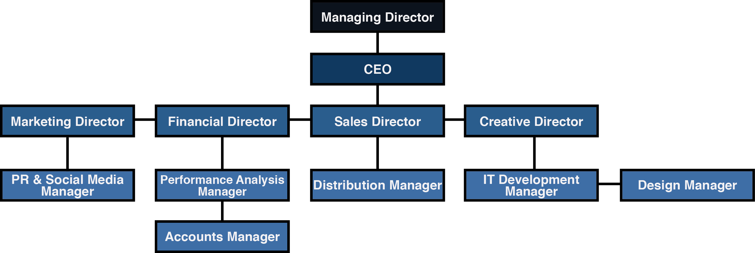

# Section 6 - Marketing

## **Market Research**

The market research we conducted allowed us to gather data on potential customers. The collected data aided us on our business decision making, therefore reducing the risks involved in making these decisions.

### 

### Primary Research

As part of our primary research we conducted:

1. Online Surveys
2. Interviews
3. Focus Groups

Carrying out our own primary research allowed us to address issues specific to our own situation. It also enabled us to have a higher level of control over how the information is collected.

**1. Online Surveys**

We sent out an online survey and received 86 responses. 74% of respondents were students, and 81% were aged between 13-25. The purpose of the survey was to gain an understanding of how people currently use their phones, how they take notes, how they cope with remembering timetables and other valuable consumer information. The comprehensive results of the survey can be found in the appendices.

Observations:

The results of our survey show that 90% of people already use their phones regularly in class. The results also show that 50% of people believe that using your phone or laptop is a more effective way of [categorizing](https://www.google.ie/search?espv=2&biw=1279&bih=636&q=categorizing&spell=1&sa=X&ved=0ahUKEwjjweTd4qvJAhXD6A4KHQmpAhkQBQgZKAA), sorting and accessing notes than traditional pen and paper. Of the 86 people surveyed only 8% of people believe that your phone would be the most effective, despite the fact that 91% claim that their phone is most easily accessible to them during the day.

Notably, 60% of people currently find it difficult to transfer their notes from their phone to their laptop, while 82% say that they would share their notes with friends and classmates if there was an easy way to do so.

66% of people often find their schoolbags too full, while 35% claim to already use a notes app.

Analysis:

We believe the reason that only 8% of people believe that your phone is the most effective way to [categoriz](https://www.google.ie/search?espv=2&biw=1279&bih=636&q=categorizing&spell=1&sa=X&ved=0ahUKEwjjweTd4qvJAhXD6A4KHQmpAhkQBQgZKAA)e, sort and access your notes is that it is currently very difficult to transfer text files from your phone to your laptop. With our cloud based storage, we make it easy for users to access their notes via multiple platforms; whether it be their phone, laptop or tablet. We believe that this feature will make your phone a more viable option for note taking. Furthermore, as 91% of people agree that your phone is the most easily accessible throughout the day we believe that the phone could become the a very dominant medium for note taking.

2-in-3 people often find their schoolbags too full, our app will cut down the amount of paperwork required to be hauled to school every day. This will help relieve physical stresses on the body, and result in greater productivity for the user.

In addition to the above, our survey shows that there are 90% of people already using their phones during class and 35% of people already using a notes app, we can conclude that there is a market for our product.

**2. Interviews**

We conducted two interviews with college students, who we believe are our main target market. The two comprehensive interviews can be found in the appendices.

Observations:

Some of the great things with face to face meetings is that we were able to capture verbal and nonverbal cues, emotions and behaviors. We were able to get real information directly from the market we wanted instead of receiving results from an anonymous survey. The interviewee thought it would be very important to have integrations in the app, allowing students to download notes from blackboard and dropbox.

Analysis:

We conclude that to make this app stand out, we need to have integrations and a cloud storage service, which will make it easier for students. Many students despise blackboard, as it is very disfunctional. Our interviewee stressed that this could be an alternative to blackboard, and many student would download our app just for this feature.

**3. Focus Groups**

We conducted a focus group with 4 students. We proposed our product idea and showed them initial design concepts. Meeting with the target market face-to-face allowed us to gage an understanding of their needs and wants.

Observations:

The group was interested in our product idea. The agreed that there was an existing issue with timekeeping among students. It was nearly the end of the semester and one member of the focus group admitted that she forgets class start times regularly. They also confirmed that they use their phones in class, and that their phones are often the most easily accessible to them throughout the day. They conceded that, with the right app, notes could effectively be taken and organised on a phone.

Analysis:

From the focus group we took good great confidence that there is a demand for our app. The members of the group seems interested in our idea, and they admitted that it would be something that they would use. Our primary research has given us great confidence in our app would have a place in the market.

### Secondary Research

We studied published texts in order to gain information on the following:

1. Target Market
2. Mobile Collaboration Learning Technique on Students in Developing Nations
3. Mobile Marketing Statistics 2015

The links to all of the relevant documents can be found in the appendices.

**1. Target Market**

We were able to accurately determine the size of our target market by reading reports on education statistics in Ireland, the UK, the US and Canada.

Ireland - In 2014/2015 there were 339,207 students in Second Level education. This includes students in Secondary (190,587), Vocational (91,612) and Community and Comprehensive (57,008) schools. In addition, there were also 33,089 Second-level Students in PLC Courses.

In total, there were 173,649 Third Level students during this school year. Universities accounted for 95,120, Institutes of Technology accounted for 68,324, Teacher Training Institutions had 6,953 students, and Other Aided Institutions accounted for 3,252 students.

UK - At the end of 2013, 3.03 million people aged 16 to 24, or 42% of the total, were in full time education.

America - The latest figures available in 2015 show that the US has a total of 4,726 Title IV-eligible, degree-granting institutions: 3,026 4-year institutions and 1,700 2-year institutions. The US had 21 million students in higher education and also has 14.9 million student in grades 9 through 12.

**2. Mobile Collaboration Learning Technique on Students in Developing Nations**

’This report was compiled in 2015 by the World Academy of Science, Engineering and Technology. It outlines how the use of technology in education in developing countries can affect student’s learning abilities in a positive way.

It states that ‘Modern technologies, if used appropriately, have been shown to enhance communication and critical thinking skills, develop lifelong learning behavior and facilitate student engagement in ways that promote a deeper understanding of coursework’.

It also referenced that ‘over 90 percent of students with a mobile device used it to accessed course syllabus, presentations, assignments and other course material regularly.’

The report concluded; ‘The study showed that the use of mobile collaborative learning technique was successful, and improved on learner’s outcome of students.’

**3. Mobile Marketing Statistics 2015**

This article was compiled in 2015 by Danyl Bosomworth of www.smartinsights.com. The statistics in this article are updated regularly. The article outlines statistics on mobile usage and mobile advertising. It helped inform our marketing and sales strategy.

It shows that mobile media time Is now greater than desktop and other media. The latest data shows that mobile users in the US now spend an average of 2.8 hours per day on their phones, and just 2.4 hours on their laptops. This means that mobile digital media time in the US is now significantly higher at 51% compared to desktop (42%). Other connected devices make up the remaining 7%.

This article also shows research sourced from a 2015 study by eMarketer into mobile ad budgets. This research shows that in 2015 mobile ad spending accounts for 49% of digital ad spending, which is only slightly behind the trends of how people are using their devices. These stats also show projections for future growth, which is important as it shows where the market is going. The report concludes that mobile is the future, and within 3 years it will come to dominate digital ad spending.

## Market Trends or Issues

We studied a report which contained some interesting information about the trends of the Apple and Google App Stores. The link to the report can be found in the appendices.

The Google Play store has become substantially more welcoming to startups this year compared to two years ago. In 2013, apps most frequently moved only 1-2 slots on the download rankings, meaning if an app became #1, it was very difficult to displace. Now, apps’ rank volatility is far more uniformly distributed, meaning mobile apps are moving up and down all the time, implying strong competition and a vibrant market. The typical app now swings 10-30 ranks per month compared to 1-5 ranks two years ago. This means there is much more jockeying for position, and it is allowing new apps to break into the top download rankings.

The counterpoint to a greater ease to reach the top of the rankings is that it’s easier to fall as well. Staying at the peak of the charts now demands more sophisticated monetising strategies, but more importantly, developing differentiated products. In addition, the increasing efficiency of mobile app marketplaces means very few apps are unassailable. The successes of mobile-first social networks like Instagram and SnapChat, despite Facebook’s dominant position in social networking, are concrete examples of this trend. Because of the greater efficiency of these marketplaces, the best apps will rapidly rise to the top and others will quickly fall out of favor. In short, it’s a great time to be a mobile startup with a good product.

## Customers

The main customers for or app Planote will be Second and Third-Level students. In Ireland, during the 2013/2014 school year, there were over 367,000 Second-Level students and 169,000 Third-Level Students. Shortly after our Irish App Store releases we will release the app in other English speaking countries such as the UK and America. Combined, the UK and America have approximately 38.93 Million students between the ages 14-24.

In order to reach this market we intend to implement an Indirect Sales Strategy. Another term given to this strategy is ‘Positive Selling’. Our indirect sales technique will apply a subtly competitive sales method by demonstrating features and benefits not available with our competition’s products or services without ever mentioning them by name. Essentially, we want customers to know that our app is unique and better than anything else on the market. This sophisticated, positive sales strategy requires research and analysis of the competition, which we have done extensively. Our sales strategy will include product placement, promotion and testimonials.

**Customer Service**

Studies show that it is five times more difficult to gain a new customer than it is to keep an existing one. It is our view that customer retention is very important. It will be of utmost importance for us to keep in contact with our existing customers, as a happy customer can become an ambassador for our product.

We would also consider it very important to be seen helping those who have an issue with our product. Negative reviews on the App Store will be dealt with very professionally, and with the customers needs in mind. If a customer is dissatisfied with our product, the first response should be to try rectify the issue. If the customer feels that the issue cannot be rectified, we can then offer a full or partial refund on the subscription cost

## Competitors

We took a look at other products on the market that could be in direct competition with our product. We evaluated their strengths and weaknesses:

|  |  |  |
| --- | --- | --- |
| App | Strengths | Weaknesses |
| Year of Release: 2012  Name: Timetable++ Schedule  Downloads: 20,000 Monthly Worldwide, Apple App Store.  Sales: <5,000 Monthly Worldwide, Apple App Store. | * Full calendar * Task Tracking * Notifications * Note taking * Exams and Marks * Pictures and audio recordings * Attendance Tracking * Share your timetable * Unlimited number of timetables * Widgets | * Clunky Interface * Notes can not be uploaded to computer * Ads can not be removed * Notes cannot be shared |
| Year of Release: 2011  Name: Class Timetable  Downloads: 51,000 Monthly Worldwide, Apple App Store  Sales: <5,000 Monthly Worldwide, Apple App Store. | * Timetable * Task tracking * Class notifications * Timetable export * Task reminders * Nice Interface * Widgets * Upgrade to pro for just 99c | * No cloud storage * No grade tracking * No timetable and note sharing * No attendance tracking * No grade tracking |
| Year of Release: 2009  Name: iStudiezPro  Downloads: 5,000 Monthly Worldwide, Apple App Store  Sales: <1,000 Monthly Worldwide, Apple App Store. | * Timetable * Manage deadlines * Track grades and * Cloud syncing | * iPhone Only * Cant take notes * costs 2.99 * Interface is old |

We developed a SWOT analysis to identify the strengths and weaknesses of our product in a market with such competitors.

|  |  |
| --- | --- |
| Strengths | Weaknesses |
| * Intuitive Interface. * Cloud-Based Storage. * Multiple timetables. * Note taking. * Grade & Attendance tracking. * Timetable & Note Sharing. | * Only facebook login. * Doesn’t support audio files. * No tablet support. (In Development) |
| Opportunities | Threats |
| * No product exactly like ours. * Huge target market. * Easy to implement our channels of distribution. | * Crowded marketplace. * Tough competitors. * Limited financial backing. |

## 

## Promotion

(Use the table below to provide details of the promotional plan)

|  |  |  |  |  |
| --- | --- | --- | --- | --- |
| Method | How | When | Result | Cost |
| Teaser Website | Build a Teaser Website | One Month Before Launch | Build up excitement before app launch | Free - 100 euro |
| Social Media | Use social media to promote our product | Beginning one month before launch and continue after launch | Consumers find out about our product | Free |
| Review Websites |  | At launch and afterwards | Generates a lot of buzz for your app if mentioned on the site | Free |
| Integrate Social Media | Encourage users to share the app with their friends by offering referral discounts | At launch and afterwards | More Downloads & Sales | Free |
| Win Awards | Apply for awards i.e. CIT Prize for Innovation | Entries by 12/02/16 | Product recognition & Prize money for development funding | Free |

## Place/Channels of Distribution

The channels of distribution for Planote will be through the the Google Play Store. Later development will see us release the app on the Apple App Store. These two App Stores have an huge user base, and will enable us to reach millions of consumers every day.

**Google Play Store**

The Google Play Store serves as the official app store for the Android operating system, allowing users to browse and download applications developed with the Android SDK and published through Google. There are currently 800 million active Android Devices capable of downloading apps from the Google Play Store.

To date there have been 1,500,000 apps published on the Google Play Store, and an estimated 150 Billion Downloads. Of the 1,500,000 available apps 1,300,000 are free and 200,000 are paid. The average number of downloads per app is 100,000. Google takes 30% of all revenue generated through apps, and 70% goes to the app's publisher.

**Apple App Store**

The Apple App Store is a digital distribution platform for mobile apps on iOS, developed and maintained by Apple Inc. The service allows users to browse and download applications that are developed with Apple's iOS SDK. The apps can be downloaded directly to iOS devices such as the iPhone, the iPod Touch, iPad, or onto a personal computer via iTunes. The App Store has an audience of 500 Million active daily users.

As of June 8 2015, there are 1,400,000 apps on the App Store with a total of over 100 Billion downloads. That is an average of 62,500 downloads per app. Apple takes 30 percent of all revenue generated through apps, and 70 percent goes to the app's publisher.

Combined, these two app stores provide 100 Million daily users.

## Business Opportunity

There are many reasons to believe that our business has a good chance of becoming successful. Our debut app ‘Planote’ is a unique app which solves a problem that all students have. Our research shows that releasing our app in the Irish, British and American app stores will give us the opportunity to sell our product to over 40 Million Students. If just 1% of this market downloads our app we will have 400,000 users. Our channels of distribution are easy to implement, and will allow us to reach over 1 Million users every day. Our research shows that money in mobile app sales and advertising is increasing year-on-year, and that market trends indicate that this is a great time to be a startup in the App Development market.

# Section 7 - Finance

## Pricing

After our research on pricing, we decided that Planote will be monetised using a subscription model. Businesses with subscription revenues tend to be valued highly as there is a guarantee of repeat transactions. Subscriptions are a regular fixed fee that the user is automatically charged at set intervals for using the app. A subscription price is usually smaller than a one-time price to incentivize the user into a longer term commitment.

Subscriptions can actually overlap with Freemium models. Freemium is where the app is free to download and use but some premium features inside the app are blocked until you pay for them. According to a report by Distimo and Saas, Freemium now accounts for 78% of Apple App Store revenues in the US and Europe, up from around 59% last year, and rising.

After much discussion on the subscription fee, we decided on a monthly subscription fee of €1.99. We felt that charging more would discourage people from paying, while charging less would give the impression that our app is cheap and therefore not worth investing in at all. We also will be offering promotional discounts. Referring a friend to download our app will give you a discount of 50% on your next purchase, while you can also buy a year’s membership for €13.99, saving the customer 40%.

In conclusion, Planote will be free to download, but you will need to pay a yearly subscription fee of €1.99 in order to unlock the premium features of the app. We will receive 70% of this fee, while the remaining 30% goes to the distribution partner and operating fees. Incorporating referral discounts on the normal subscription price will motivate current customers to spend their money and to spread the word to others.

## Sales assumptions

|  |  |  |
| --- | --- | --- |
| Month | Sales (€) | Notes |
| February | 50 | First Month In Business |
| March | 150 | Entering Exam Season |
| April | 350 | In Exam Season |
| May | 700 | Height of Exam Season |
| June | 700 | Height of Exam Season |
| July | 300 | Summer Break |
| August | 700 | Release in UK & US - Still Summer Break |
| September | 3000 | College Year Begins |
| October | 5000 | App becomes more well known |
| November | 7000 | Exams Approaching |
| December | 9000 | Exam Season - Time of year for spending |
| Total | 26,950 |  |

## 

## Exports

N/A

## Funding

We will be starting his company with little funding. We will be building this company from personal finances and from the operating revenues of the new company.

|  |  |  |  |
| --- | --- | --- | --- |
| Project Costs | € | Sources of Funding | € |
| Product Development | 0 |  |  |
| Marketing | 1,000 | Family/Friends | 10,000 |
| Hiring Costs | 0 | Banks | 25,000 |
|  |  | Angel Investment | 0 |
| Other: | 0 | Venture Capitalists | 0 |

## Capital Costs

|  |  |  |  |
| --- | --- | --- | --- |
| Capital items owned | Value (€) | Capital items Required | Value (€) |
| Equipment/tools | 5,000 | Equipment/tools | 2000 |
| Fixtures & fittings | 0 | Fixtures & fittings | 0 |
| Vehicles | 7,000 | Vehicles | 0 |
| Security & Safety | 0 | Security & Safety | 1000 |
| ICT | 0 | ICT | 300 |
| Office Furniture | 0 | Office Furniture | 1,000 |
| Total | 12,000 | Total | 4,400 |

## Fixed costs

|  |  |
| --- | --- |
| Fixed costs | € |
| Rent & rates | 0 |
| Heat & power | 0 |
| Tel & internet | 1,000 |
| Vehicle expenses | 7,000 |
| Advertising & promotion | 2,500 |
| Marketing Costs | 2,500 |
| Office supplies and postage | 500 |
| Sundries | 0 |
| Accountancy & legal | 2000 |
| Insurance | 1,000 |
| Sundries | 0 |
| Staff costs | 0 (Year 1) |
| Finance charges | 0 |
| Other | 2,000 |
| Total | 17,600 |

## Variable costs

|  |  |
| --- | --- |
| Product | Costs Per Annum € |
| Stock | 100 |
| Materials | 300 |
| Domain Names + https | 300 |
| Total | 700 |

# Apendices

## Survey

Which age bracket do you fit into?

* Less than 13
* 13-18
* 19-25
* 26-35
* 36-50
* Over 50

What's your job title?

* Unemployed
* Part-time
* Full-time
* Self-employed
* Student
* Student & Working Full Time/Part Time

Do you own any of the following?

* Android Phone
* Iphone
* Windows Phone
* Other

What do you most use your phone for?

* Text/Phone Call
* Social Media
* Messenger Apps
* Gaming
* Photography
* Note taking
* Watching Video Content (Netflix etc)
* Other (please state)

Do you use your phone in class?

* Yes, Every Class
* Yes, Occasionally
* Depends on The Class/Lecturer
* No

What do you usually use to take notes in class?

* Pen and Paper
* Laptop
* Phone

Which of the these methods do you think would be easiest to categorise, sort and access your notes?

* Pen and Paper
* Laptop
* Phone

Which of these is most easily accessible to you throughout the day?

* Phone
* Laptop
* Notepad & Pen

Do you ever find your school bag too full?

* Yes
* No
* Sometimes

Do you ever forget the start/end times of your classes?

* Yes
* No
* Sometimes

Are you ever late for classes, deadline or important meetings as a result of having the wrong time?

* Yes
* No

Would you share notes with friends more often is there was an easy way to do so?

* Yes
* No
* Maybe

Do you use your phone's timetable/calendar application?

* Yes
* No

Do you use a notes app?

* Yes
* No

Would you use an app that integrated both taking notes and your class/work timetable?

* Yes
* No
* Maybe

Do you use Cloud-based software/programs such as Dropbox, Google Drive or Skydrive?

* Yes
* No

Do you currently find it difficult or time consuming to transfer text files and documents from your phone to your PC/Laptop?

* Yes
* No

Bibliography

### 

Irish Student Figures:

<https://www.education.ie/en/Publications/Statistics/Key-Statistics/>

World’s most educated countries:

<http://newsfeed.time.com/2012/09/27/and-the-worlds-most-educated-country-is/>

Education Statistics US:

<https://en.wikipedia.org/wiki/Higher_education_in_the_United_States>

<http://nces.ed.gov/fastfacts/display.asp?id=372>

Education Statistics UK:

<https://www.hesa.ac.uk/stats>

<https://www.hesa.ac.uk/intros/stuintro1213>

Mobile Marketing Statistics 2015:

<http://www.smartinsights.com/mobile-marketing/mobile-marketing-analytics/mobile-marketing-statistics/>

Mobile Collaboration Learning Technique on Students in Developing Nations:

<http://waset.org/publications/10002606/mobile-collaboration-learning-technique-on-students-in-developing-nations>

Channels of disctribution <http://venturebeat.com/2013/02/06/800-million-android-smartphones-300-million-iphones-in-active-use-by-december-2013-study-says/>

<https://en.wikipedia.org/wiki/App_Store_(iOS)>

<https://en.wikipedia.org/wiki/Google_Play>

Market trends

http://tomtunguz.com/app-store-competition/

Sales strategy

<http://smallbusiness.chron.com/sales-strategy-629.html>

<http://smallbiztrends.com/2011/11/5-keys-successful-sales-strategies.html>

Customer service

<http://smallbusiness.chron.com/create-customer-service-plan-2047.html>

<http://www.ipsos.com/loyalty/sites/ipsos.com.loyalty/files/Ipsos_Loyalty_Myth_8_Excerpt_0.pdf>

## Survey Results

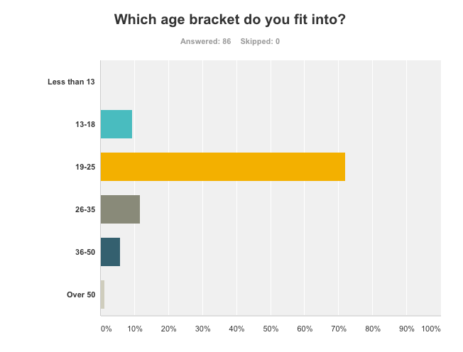

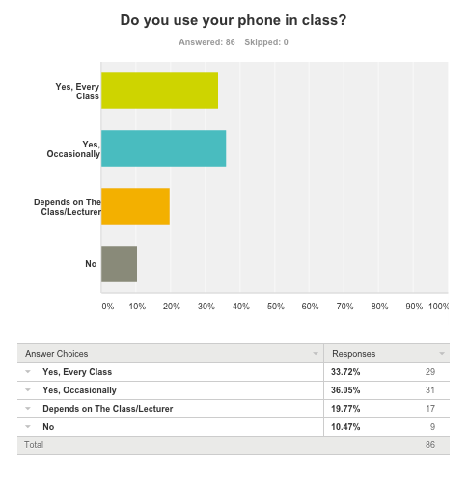

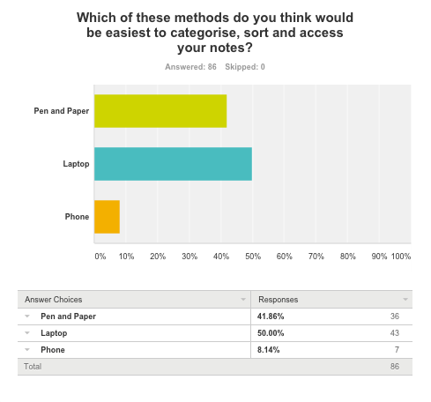

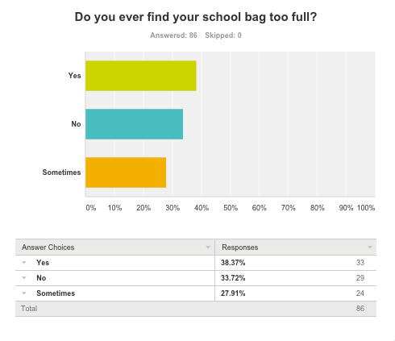

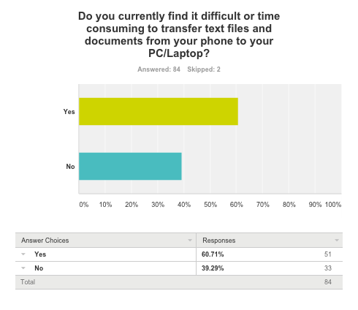

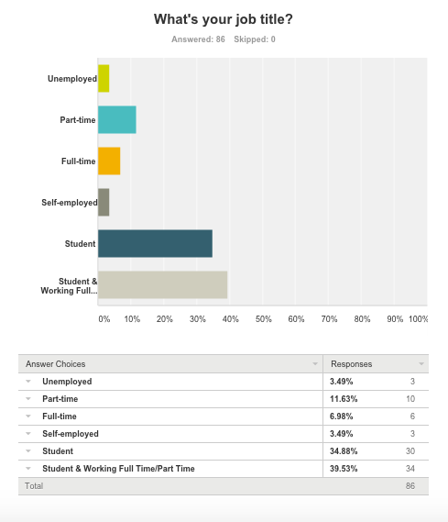

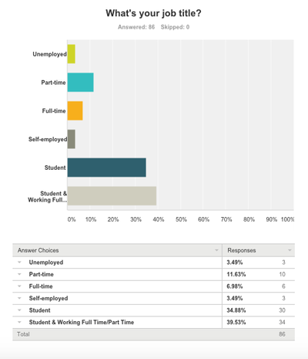



# Meetings

## Meeting 1

Date: 2nd Oct 2015

Attending: Brie, Robert, Peter

Points Discussed

* Brainstorming ideas for a potential app
* Narrowed down to 3 potential ideas
* Conduct research on these potential app ideas

## Meeting 2

Date: 5th Oct 2015

Attending: Brie, Robert, Peter

Points Discussed

* Decided on app idea - for note taking/organisation
* Updating the blog

## Meeting 3

Date: 10th Oct 2015

Attending: Brie, Robert, Peter

Points Discussed

* Current findings on other note taking/timetable applications
* Organising of presentation slides

## Meeting 4

Date: 14th Oct 2015

Attending: Robert, Peter

Absent: Brie

Points Discussed

* Working on business proposal
* Functions and features of the app
* Target market - students, lecturers
* Current competitors in the market

## Meeting 5

Date: 18th Oct 2015

Attending: Brie, Robert, Peter

Points Discussed

* Business proposal and sections that need updating to finalise for submission
* Design concepts
* Role allocation

## Meeting 6

Date: 28th Oct 2015

Attending: Brie, Peter, Robert

Points Discussed

* Went over presentation
* Survey and executions - print out of survey monkey
* Design layouts

## Meeting 7

Date: 3rd Nov 2015

Attending: Brie, Peter, Rober

Points Discussed

* Survey results to date
* Usability features for the app
* Blog update

## Meeting 8

Date: 10th Nov 2015

Attending: Brie, Peter, Robert

Points Discussed

* Brand names and logo ideas
* Business plan

## Meeting 9

Date: 18th Nov 2015

Attending: Brie, Peter, Robert

Points Discussed

* Business plan
* Secondary research
* Design developments
* Usability testing

## Meeting 10

Date: 3rd Dec 2015

Attending: Brie, Peter, Robert

Points Discussed

* Finalisation of presentation
* Presentation rehearsal

## INTERVIEWS

Interviewer: Robert Gabriel

Interviewee: Marybeth O'Connor

Date: 21/10/2015

What's your name:

Marybeth O’Connor

What year are you in?

3 year BIS

May I ask, what type of phone do you have

I have an Iphone 5c

How do you study?

I study mostly with books and my phone for searching

So do you use your phone in class?

Yeah mostly for texting and taking notes.

Oh for notes, what apps do you use?

Well, I mostly use Evernote. But it's limiting.

Why is it limiting?

The lack of-of usability and I cannot get the notes as a pdf or get them off blackboard!!

So what would you change?

I would have a clear interface and it should give me access to all my other apps would be great. As teachers use different services to host their notes. Some use blackboard, some use blogger and some email it would be great if I could have them all in one.

Oh that's great to hear, I think thats everything I need to hear. Thank you for your time Mary you have been amazing.

## Screenshotshuawei_p8_by__claudioguglieri.pnghuawei_p1_by__claudioguglieri.png

